44.45: The available energy must be the sum of the final rest masses: (at least)
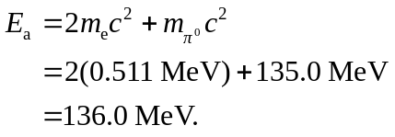
For alike target and beam particles: 